Perceptual learning in children with autism spectrum disorder (ASD).

# Introduction

# Methods

## Participants

Twenty-five children with ASD between 10 and 14 years old and 25 TD children between 10 and 14 years old completed the motion direction estimation task in this study. All participants were Dutch-speaking and reported normal to corrected-to-normal vision. Participant characteristics of both the ASD group and the TD group can be found in Table x. Participants with and without ASD were group-wise matched based on intelligence, age and gender ratio (see Table x).

The children with ASD all had a formal clinical diagnosis of ASD and were diagnosed according to DSM-VI-TR criteria (American Psychiatric Association, 2000) in a multidisciplinary team or by a child psychiatrist. Recruitment was set up via the Autism Expertise Centre of the University Hospital in Leuven. As part of the study protocol, ASD diagnoses were re-evaluated with the Dutch version of the Autism Diagnostic Observation Scale 2 (ADOS-2) module 3 by a trained clinical psychologist. All ASD diagnoses were reconfirmed with the ADOS-2 algorithm for DSM-5.

For the TD group, children were recruited via mainstream schools. Children with a first-degree family member with a developmental disorder or children with a known child psychiatric disorder (information gathered from parents) were excluded.

Intellectual abilities for all participants were estimated by administering an abbreviated version of the WISC-III-NL. ASD symptoms were evaluated using the Dutch version of the SRS-2. In order to explore potential relationships between task performance and everyday sensory processing, parents were asked to complete the Sensory Profile (SP-2;Dunn, 2014).

## Apparatus and Stimuli

Stimuli were displayed on a XXX? in a quiet and darkened room. Viewing distance was approximately 57 cm. Stimulus presentation, timing, keyboard responses and data collection were controlled using the Psychopy package (Peirce,2007,2009).

A white-bordered circular aperture (15° diameter) and a centered black fixation point (0.10° diameter) were presented on a grey screen. Motion stimuli consisted of 100 white dots (0.44° diameter) moving for 600 ms within the circular aperture with a dot speed of 3°/second and an unlimited lifetime. Dots that moved outside the aperture were placed at the opposite side of the aperture.

The mean directional offset could be one out of eleven different directions [-50°, -40°, -30°, -20°, -10°, 0°, +10°, +20°, +30°, +40°, +50°]. To manipulate the level of noise in the stimuli, the direction of each dot was sampled from a normal distribution with one of the eleven different directions as a mean direction. The standard deviation of the normal distribution of directions was varied. In the low-noise condition, the standard deviation of the directions was 10° and in the high-noise condition the standard deviation of the directions was 40°.

## Procedure

This study was approved by the ethical committee of the university hospitals UPC-KU Leuven and was incorporated within a larger study on perceptual learning in children with ASD. Parents and children gave their written informed consent before participation. A book voucher was given to the child and transportation costs were reimbursed.

## Motion direction estimation task

The task was developed as a game in which the children are participating in a big fishing contest. The children were told that they were competing against a computer character, the champion of last year’s fishing contest. The goal of the fishing contest was to catch as many fish as possible. At the start of each trial, a black fixation point was presented within the white-bordered circular aperture (1000 ms). Next, the moving dot stimulus was presented (600 ms) and the children were told that these white dots were the swimming fish. After the moving dot stimulus, a fishing rod was presented and the children had to report the direction of the moving dots by adjusting the orientation of the fishing rod until it matched their perceived direction. When they were sure about their response, they had to press the spacebar. Then a confirmation of their response was given by presenting the rod for 100 ms. At the end of the trial, feedback was given by showing the true mean direction of the moving dots with a white line (100 ms).

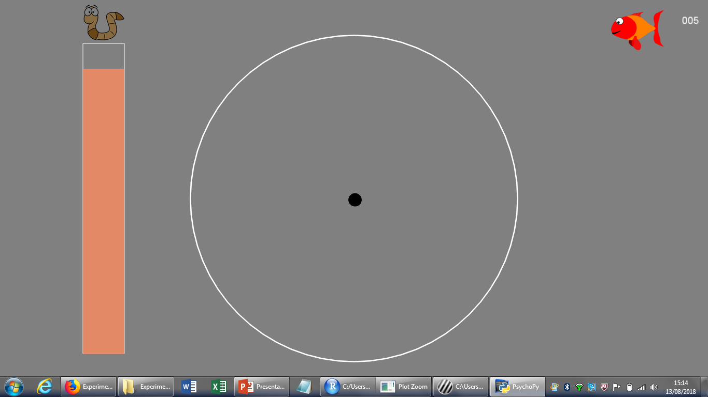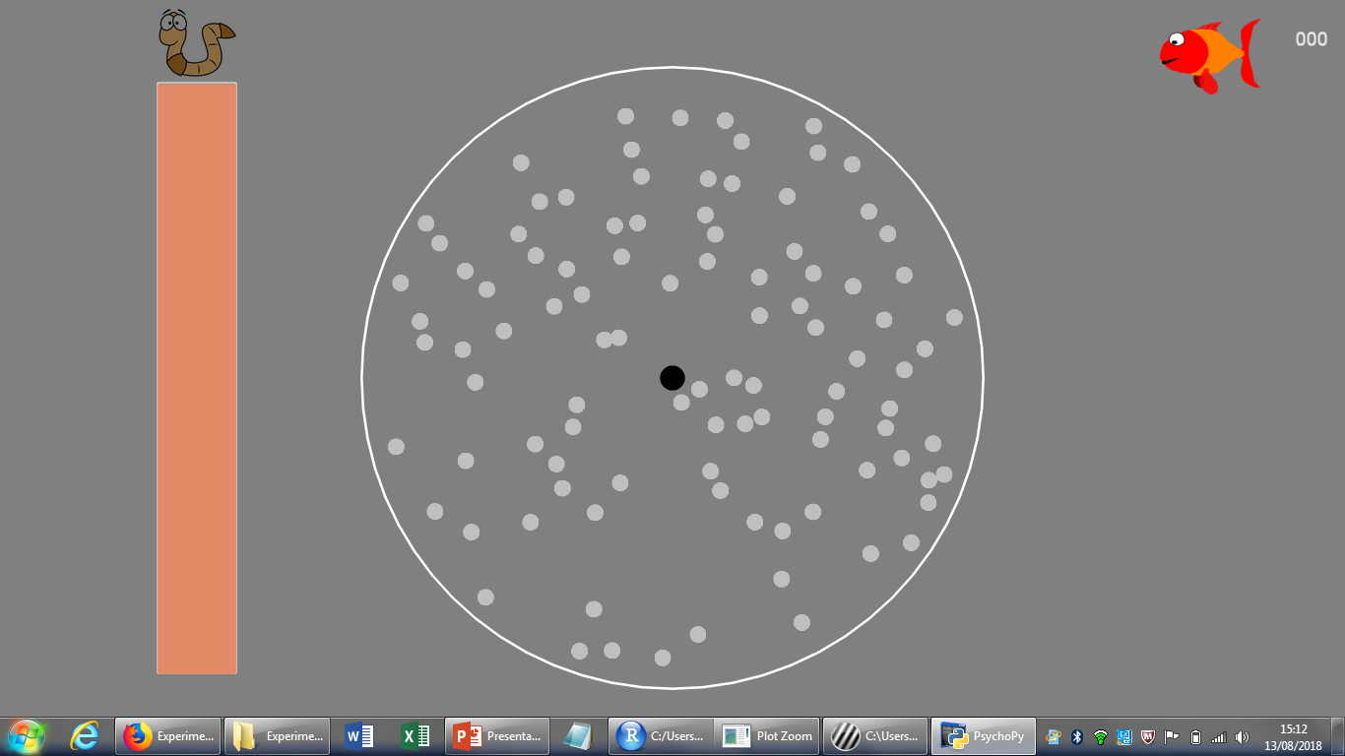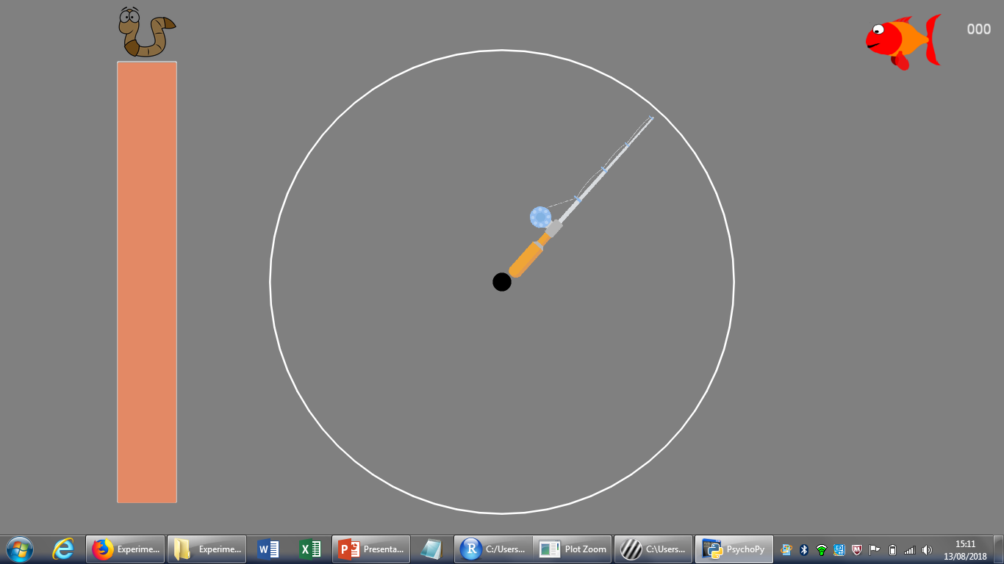

600 ms

1000 ms

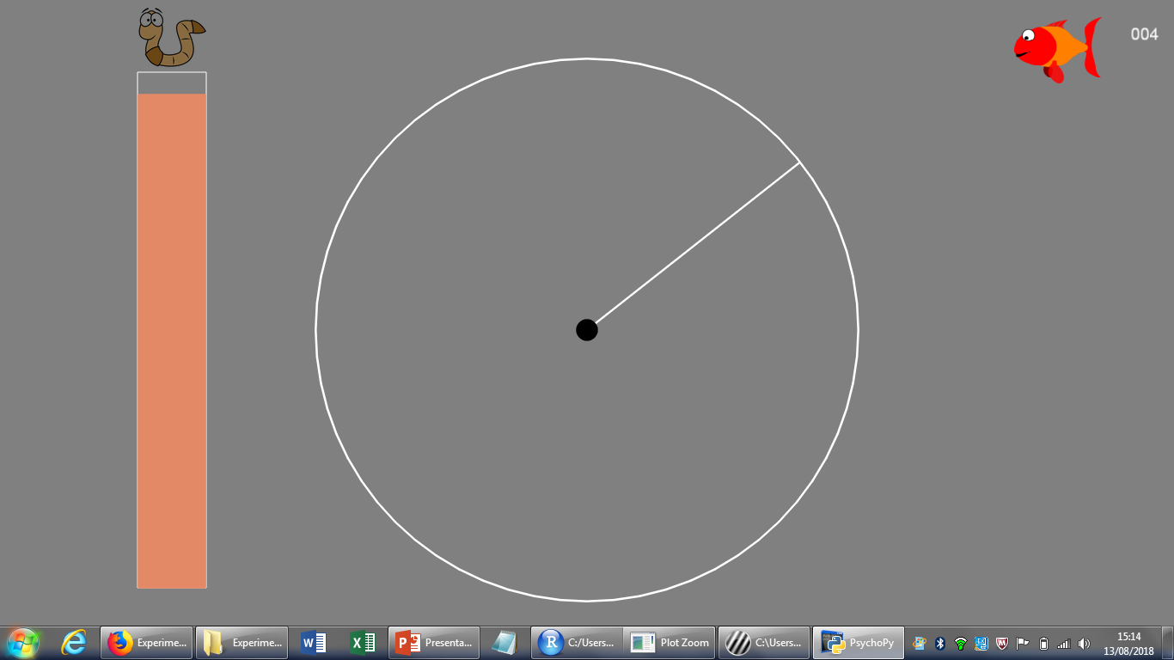

Fixation

Motion

Response

Confirmation

Feedback

Untill response

100 ms

100 ms

The task consisted of 8 blocks of 50 trials each, with a total of 400 trials. In between blocks the participants could take a self-paced rest.

* First 6 blocks (300 trials), the prior mean was constant (22° or 68°) , last 2 blocks shift in the prior mean (68° or 22°). (Counterbalanced, but not really in balance..)

Prior means ASD group: 10 participants 22° prior mean first, 14 participants 68° prior first.

Prior means TD group: 11 participants 22° prior first, 14 participants 68° prior mean first.

# Results